

SUPPLEMENTAL APPLICATION

*Please Print Legibly*

Name: __________________________________________________________________________________________________
Last First Middle (Full Name)

Address: _________________________________________________________________________________________________

City: _______________________________ State: ____________________ Zip: __________________

County: _____________________________ DOB: __________________ Gender: ________________

City of Birth: _____________________________________________________________________________________________

State of Birth: ____________________________________________________________________________________________

County of Birth: __________________________________________________________________________________________

Country of Birth: __________________________________________________________________________________________

Country of Citizenship: ____________________________________________________________________________________

Home Country Address (if applicable): ____________________________________________________________________

SSN: _____________________________ Email: _______________________________________________

Home Phone:___________________________ Cell Phone:____________________________________

Religion:

Veteran: YES____ NO____ If yes, please list Service Branch:

Emergency Contact: ___________________________________ Relationship: _____________________

Address: ____________________________________________________________________________

City, State, Zip: __________________________________________ Phone Number: _______________________

Ethnicity (Optional)
Please check all ethnicity classifications that apply to you:

___ American Indian/ Alaskan Native
___ Asian
___ Black/African American
___ Hispanic/Latino
___ Native Hawaiian/Other Pacific Islander
___ White/Caucasian
____ Other

Education:
(please put a check mark by ALL levels of education you have completed)

___ High School Diploma
___ GED
____Other
___ Some College/University
___ Associate Degree
___ Bachelor’s Degree
____Some Graduate
___ Master’s Degree
___ Doctoral Degree

List ALL names on your official transcripts: (Examples: maiden name, married name):

List ALL colleges attended including Bethel: If you are still working on a degree, please list expected graduation date.

Name of Institution City/State Dates Attended Degree/Date

___________________________________________________________________ __________

___________________________________________________________________ __________

___________________________________________________________________ __________

___________________________________________________________________ __________

Delta Region: (Please refer to pg. 6 for Delta Region Map)

Are you from the Delta Region (Please see attached map and list)? ___YES ___NO

Do you plan on working in the Delta Region (refer to map and list) as a PA after graduation? ___YES ___NO

Do you plan on working in a Rural Area after graduation? ___YES ___NO

How did you hear about the Bethel University Physician Assistant Program?

PA School(s) Choice:

What are the top two most important factors for you when choosing a PA school to attend?

1._____________________________________________________________________________________________________

2._____________________________________________________________________________________________________

Criminal Background:

Have you ever pleaded guilty to or no contest to a misdemeanor criminal offense, or been found guilty by a court of such a criminal offense? _____YES ______NO

If so, for each such offense, please identify the offense, identify the state and county where the offense was committed provide the applicable case number and relevant dates, and provide all details related to the offense and the outcome of the case and the sentence imposed:

____________________________________________________________________________________________________________

___________________________________________________________________________________________________________

____________________________________________________________________________________________________________

____________________________________________________________________________________________________________

Have you ever pleaded guilty to or no contest to a felony criminal offense, or been found guilty by a court of such a criminal offense? ____YES ______No

If so, for each such offense, please identify the state and county where the offense was committed provide the applicable case number and relevant dates, and provide all details related to the offense and the outcome of the case and the sentence imposed.

____________________________________________________________________________________________________________

____________________________________________________________________________________________________________

____________________________________________________________________________________________________________

____________________________________________________________________________________________________________
*Please note that acceptance into Bethel University’s Physician Assistant Program is contingent upon receipt of negative drug screen and background check, indicating no prior convictions that would result in failure to obtain medical licensure.

If a discrepancy is reported on an incoming student’s drug screen or background check, Bethel University’s Physician Assistant Program will review the reports and it will be at their discretion to either retain the seat offer or rescind the seat offer.*

“I understand that this application form does not constitute application for admission to the specific graduate programs offered at Bethel University. Each degree program requires additional application materials and processes for formal admission into a specific program. Separate applications for degree program admission are available. I certify that none of the information on this form is false or has been withheld. I further certify that I understand giving false information or withholding information may cause ineligibility for admission or to continue my enrollment at Bethel University.”

Signature: Date: ___________________________

*Please see pg. 5 for Supplemental Application Submission and Supplemental Application Fee Payment Information.**

**Submission of Supplemental Application**

Email Completed Application: paadmissions@bethelu.edu

OR

Mail Completed Application: Bethel University PA Program
Attn: Admissions Dept.
302 B Tyson Avenue
Paris, TN 38242

**Payment Instructions**

**Payment: $75 Application Fee to Bethel University Business Office:**

Pay Online: https://payit.nelnet.net/form/NTxRIvKt
*Please note it will take 5 to 6 Business Days for your payment to be processed.*

*Your payment will not be accepted until your Supplemental Application has been received by BUPAP Admissions and uploaded to our system. You may contact the PA Program to make sure that your account has been created before submitting your online payment.*

Pay Via Phone: Please call 731-352-4050
*Please note that the Business Office cannot take your payment over the phone, until your Supplemental Application has been received by the PA Program and uploaded into our system. You may contact the PA Program to make sure that your Supplemental Application has been uploaded before calling the Business Office.*

OR

Mail Payment: Bethel University
Attn: Student Billing
325 Cherry Avenue
McKenzie, TN 38201

*Please make your check or money order of 75.00 out to Bethel University Physician Assistant Program*

*Please DO NOT mail your check with your Supplemental Application to the PA Program!*
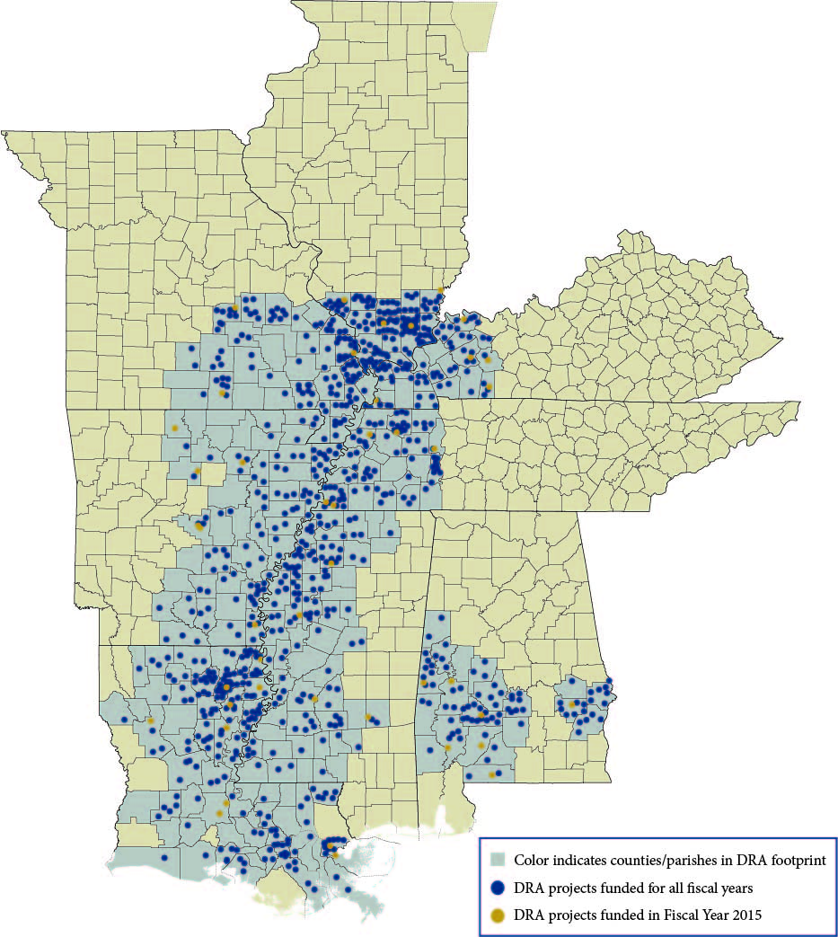
Delta Region

https://www.dra.gov/funding-programs/states-economic-development-assistance-program/

Alabama
Barbour County; Bullock County; Butler County; Choctaw County; Clarke County; Conecuh County; Dallas County; Escambia County; Greene County; Hale County; Lowndes County; Macon County; Marengo County; Monroe County; Perry County; Pickens County; Russell County; Sumter County; Washington County; Wilcox County

Arkansas
Arkansas County; Ashley County; Baxter County; Bradley County; Calhoun County; Chicot County; Clay County; Cleveland County; Craighead County; Crittenden County; Cross County; Dallas County; Desha County; Drew County; Fulton County; Grant County; Greene County; Independence County; Izard County; Jackson County; Jefferson County; Lawrence County; Lee County; Lincoln County; Lonoke County; Marion County; Mississippi County; Monroe County; Ouachita County; Phillips County; Poinsett County; Prairie County; Pulaski County; Randolph County; Searcy County; Sharp County; Stone County; St. Francis County; Union County; Van Buren County; White County; Woodruff County

Delta Region Continued

Illinois
Alexander County; Franklin County; Gallatin County; Hamilton County; Hardin County; Jackson County; Johnson County; Massac County; Perry County; Pope County; Pulaski County; Randolph County; Saline County; Union County; White County; Williamson County

Kentucky
Ballard County; Caldwell County; Christian County; Calloway County; Carlisle County; Crittenden County; Fulton County; Graves County; Henderson County; Hickman County; Hopkins County; Livingston County; Lyon County; Marshall County; McCracken County; McLean County; Muhlenberg County; Todd County; Trigg County; Union County; Webster County

Louisiana
Acadia Parish; Allen Parish; Ascension Parish; Assumption Parish; Avoyelles Parish; Beauregard Parish; Bienville Parish; Caldwell Parish; Cameron Parish; Claiborne Parish; Concordia Parish; Catahoula Parish; DeSoto Parish; East Carroll Parish; East Baton Rouge Parish; Evangeline Parish; Franklin Parish; Iberia Parish; Iberville Parish; East Feliciana Parish; Grant Parish; Lafourche Parish; Jackson Parish; Jefferson Davis Parish; Livingston Parish; Jefferson Parish; Lincoln Parish; Natchitoches Parish; La Salle Parish; Morehouse Parish; Plaquemines Parish; Madison Parish; Ouachita Parish; Richland Parish; Orleans Parish; Rapides Parish; St. Helena Parish; Pointe Coupee Parish; Red River Parish; St. Landry Parish; St. Bernard Parish; St. Charles Parish; St. Mary Parish; St. James Parish; St. John the Baptist Parish; St. Martin Parish; Tangipahoa Parish; Tensas Parish; Union Parish; Vermillion Parish; Washington Parish; Webster Parish; West Baton Rouge Parish; West Carroll Parish; West Feliciana Parish; Winn Parish

Mississippi
Adams County; Amite County; Attala County; Benton County; Bolivar County; Carroll County; Claiborne County; Coahoma County; Copiah County; Covington County; DeSoto County; Franklin County; Grenada County; Hinds County; Holmes County; Humphreys County; Issaquena County; Jasper County; Jefferson County; Jefferson Davis County; Lawrence County; Leflore County; Lafayette County; Madison County; Marion County; Lincoln County; Montgomery County; Panola County; Marshall County; Quitman County; Rankin County; Pike County; Smith County; Sunflower County; Sharkey County; Simpson County; Tippah County; Tallahatchie County; Tate County; Tunica County; Union County; Walthall County; Warren County; Washington County; Wilkinson County; Yalobusha County; Yazoo County

Missouri
Bollinger County; Butler County; Cape Girardeau County; Carter County; Crawford County; Dent County; Douglas County; Dunklin County; Howell County; Iron County; Madison County; Mississippi County; New Madrid County; Ozark County; Pemiscot County; Oregon County; Phelps County; Perry County; Reynolds County; Ripley County; Scott County; Shannon County; Ste. Genevieve County; St. Francois County; Stoddard County; Texas County; Washington County; Wayne County; Wright County

Tennessee
Benton County; Carroll County; Chester County; Crockett County; Decatur County; Dyer County; Fayette County; Gibson County; Hardeman County; Hardin County; Haywood County; Henderson County; Henry County; Lake County; Lauderdale County; Madison County; McNairy County; Obion County; Shelby County; Tipton County; Weakley County

